**Green Village Manager**

**HCI Project**

**Report for survey.**

**Certainly! Here's a structured usability test script and accompanying survey for testing a social media platform with the tasks you've outlined:**

**---**

*Usability Test Script: Aghour Elkobra Application*

**\*Introduction: \***

1. Welcome to our usability test for the Social Media Platform! Thank you for participating.

2. The purpose of this test is to gather feedback on the usability and user experience of our platform to help us make improvements.

3. During the test, I'll ask you to complete a series of tasks using the platform. Please think aloud as you go through the tasks so we can understand your thought process.

4. Your feedback is invaluable to us, and there are no right or wrong answers. We're interested in your honest opinions and experiences.

5. Before we begin, could you please tell me a bit about your experience with social media platforms? Which platforms do you use most frequently?

**\*Participant Background: \***

1. Can you tell me your age, occupation, and level of familiarity with social media platforms?

2. Have you used our Social Media Platform before, or is this your first time using it?

**\*Instructions: \***

1. I'll provide you with a series of tasks to complete using the platform.

2. Please perform each task to the best of your ability. If you encounter any issues or have any questions, feel free to ask.

3. Remember to think aloud as you go through the tasks. This will help us understand your thought process and any challenges you encounter.

4. Once you've completed each task, we'll discuss your experience and gather feedback.

**\*Task Scenarios: \***

1. *Task 1: * Log in to your account using your username and password.

2. *Task 2: * Log out of your account.

3. *Task 3: * Create a new account on the platform.

4. *Task 4: * View your list of favorite posts.

5. *Task 5: * Add a new post to your account.

6. *Task 6: * View an existing post.

7. *Task 7: * Like a post.

8. *Task 8: * Comment on a post.

9. *Task 9: * Share a post or copy its link.

10. *Task 10: * Search for a category.

11. *Task 11: * View your notifications.

12. *Task 12: * Choose a category from a list.

13. *Task 13: * Add an element (like a post or comment) in a specific category.

14. *Task 14: * change app appearance mode.

**\*Observation and Note-Taking: \***

1. As you complete each task, I'll be observing your interactions with the platform and taking notes on your actions, behaviors, and verbal feedback.

2. Please feel free to share any thoughts, frustrations, or suggestions you have as you navigate through the platform.

**\*Follow-Up Questions: \***

1. After each task, I'll ask you a few follow-up questions to gather additional insights and feedback.

2. These questions may include asking about your overall experience, any difficulties you encountered, and any suggestions you have for improvement.

**\*Wrap-Up: \***

1. Thank you for completing the tasks and providing your feedback. Your input is incredibly valuable to us.

2. Is there anything else you'd like to share before we conclude the test?

**\*Closing: \***

1. Thank you again for participating in our usability test. We'll be reviewing your feedback and using it to improve the Social Media Platform.

2. If you have any further questions or feedback, please don't hesitate to reach out to us.

3. Have a great day!

**---**

**\*Post-Test Survey\***

**\*Overall Satisfaction: \***

1. How satisfied are you with our Social Media Platform overall? (1 = Very Dissatisfied, 10 = Very Satisfied)

2. What factors influenced your satisfaction with our platform?

**\*Usability and Navigation: \***

3. How easy was it to navigate through the different features of our platform? (1 = Very Difficult, 10 = Very Easy)

4. Did you encounter any difficulties while performing the tasks? If yes, please explain.

**\*Features and Functionality: \***

5. Which features of our platform do you find most useful?

6. Are there any additional features or functionalities you would like to see added to our platform?

**\*User Experience: \***

7. How intuitive did you find the process of logging in and out of your account? (1 = Not Intuitive, 10 = Very Intuitive)

8. How easy was it to create a new account? (1 = Very Difficult, 10 = Very Easy)

9. How easy was it to add, view, and interact with posts? (1 = Very Difficult, 10 = Very Easy)

10. How satisfied are you with the search functionality on our platform? (1 = Very Dissatisfied, 10 = Very Satisfied)

11. How useful did you find the notification feature? (1 = Not Useful, 10 = Very Useful)

**\*Improvement Suggestions: \***

12. Is there anything specific you think we could improve about our platform?

13. Do you have any suggestions for enhancing the user experience or adding new features to our platform?

**\*Demographic Information: \***

14. What is your age range?

- Under 18

- 18-24

- 25-34

- 35-44

- 45-54

- 55-64

- 65+

15. What is your level of education?

- High School or equivalent

- Some College

- Associate degree

- Bachelor's Degree

- Graduate Degree

**\*Open-Ended Questions: \***

16. Please share any additional comments, suggestions, or feedback you have about our Social Media Platform.

17. Is there anything else you would like us to know about your experience with our platform?

---

This script and survey are designed to gather detailed feedback on the usability and user experience of your social media platform, covering a range of tasks and features relevant to typical user interactions.

**\*Feedback Form: \***

**1)**

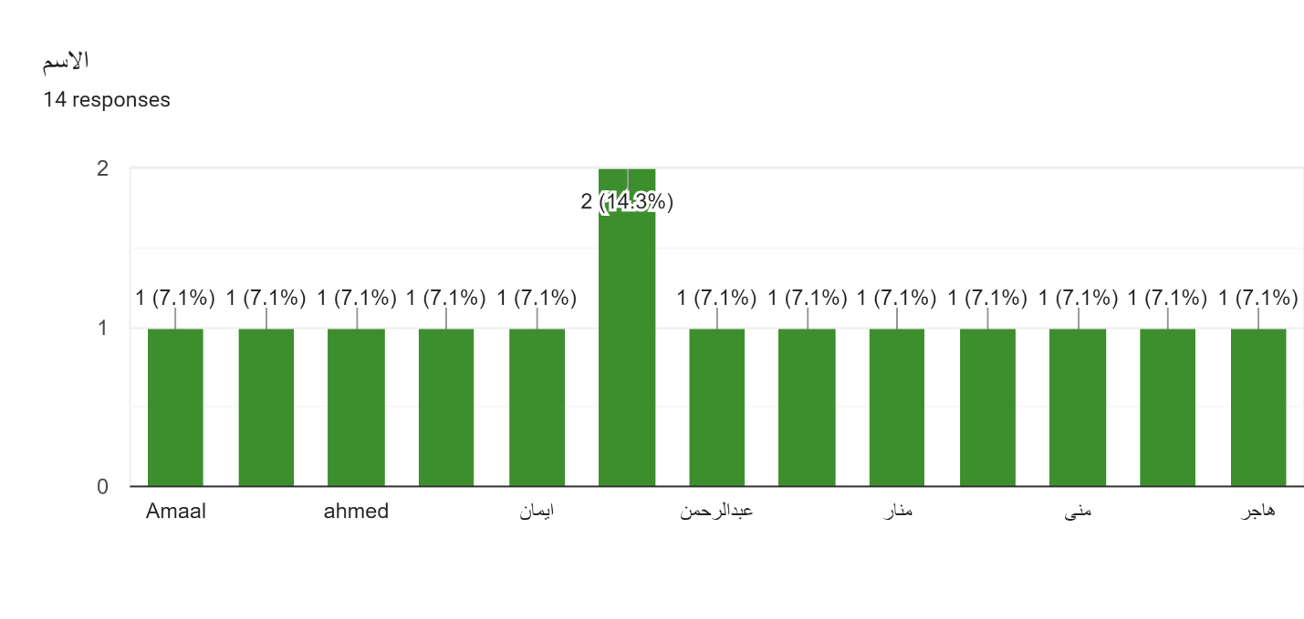

**2)**

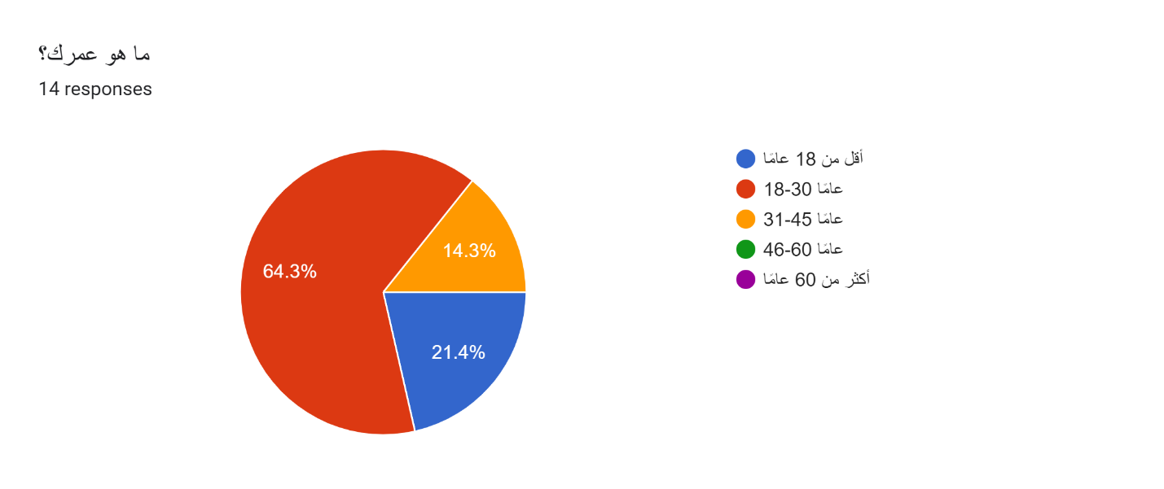

**3)**

**4)**

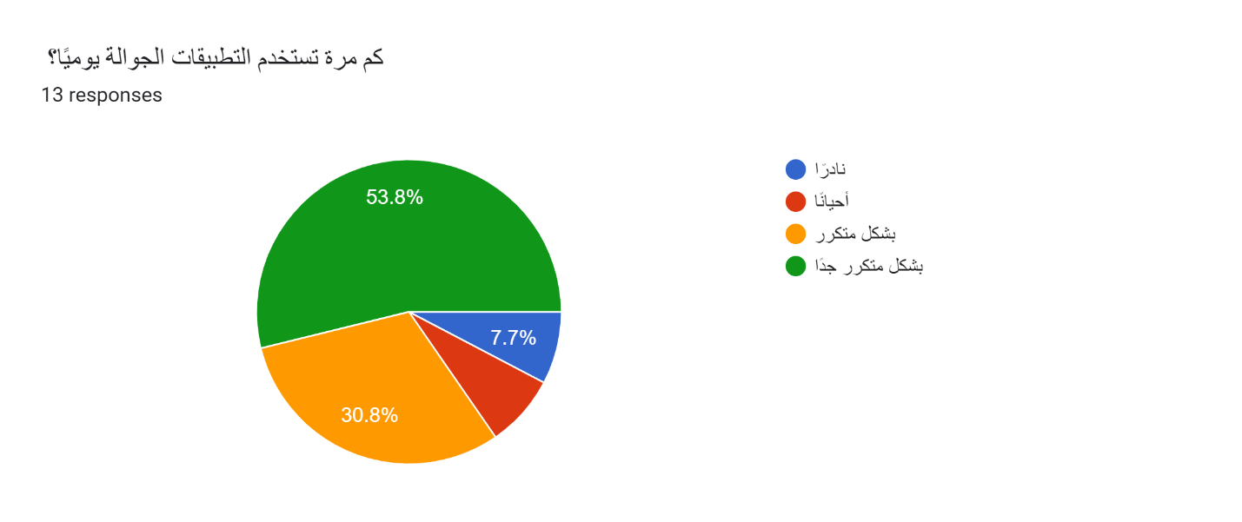

**5)**

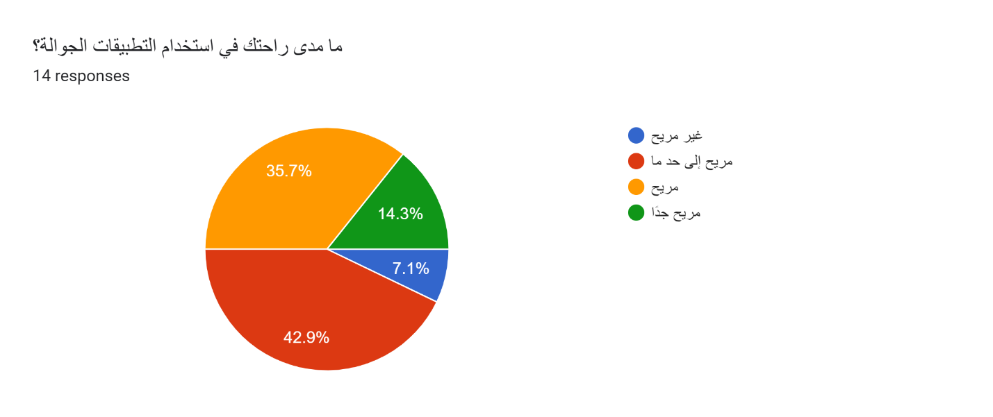

**6)**

Forms response chart. Question title: ما هي الفئات الأكثر أهمية بالنسبة لك؟ (اختر كل ما ينطبق)
. Number of responses: 14 responses.

**7)**

Forms response chart. Question title: ما مدى أهمية الميزات التالية بالنسبة لك في هذا التطبيق؟ 
 العثور على معلومات الأطباء (الموقع، رقم الاتصال)
. Number of responses: 14 responses.

**8)**

Forms response chart. Question title: العثور على معلومات المكتبات
. Number of responses: 13 responses.

**9)**

Forms response chart. Question title: العثور على معلومات المعلمين
. Number of responses: 13 responses.

**10)**

Forms response chart. Question title: العثور على معلومات الرعاية الصحية
. Number of responses: 13 responses.

**11)**

Forms response chart. Question title: العثور على معلومات الصيدليات
. Number of responses: 14 responses.

**12)**

Forms response chart. Question title: ما مدى احتمالية استخدامك للميزات التالية في التطبيق؟

تسجيل الدخول والخروج
. Number of responses: 14 responses.

**13)**

Forms response chart. Question title: تسجيل حساب
. Number of responses: 13 responses.

**14)**

Forms response chart. Question title: إضافة منشورات
. Number of responses: 14 responses.

**15)**

Forms response chart. Question title: التعليق على المنشورات
. Number of responses: 14 responses.

**16)**

Forms response chart. Question title:  الإعجاب بالمنشورات
. Number of responses: 14 responses.

**17)**

Forms response chart. Question title:  إضافة بيانات إلى الفئات (بموافقة الإدارة)
. Number of responses: 13 responses.

**18)**

Forms response chart. Question title: ما مدى أهمية القدرة على التبديل بين الوضع الليلي والوضع النهاري بالنسبة لك؟
. Number of responses: 14 responses.

**19)**

**20)**

**21)**

